

AMT Handbook



iSolutions International Pty Ltd
6-12 Atchison Street
St Leonards NSW 2065
Telephone: +61 2 9966 9096
www.isipl.com

AMT HANDBOOK


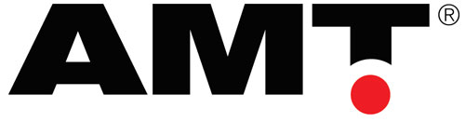

Contents
Introduction 3
AMT Footprint 4
Asset Life Cycle Costing 6
Base Principles 7
AMT Modules 8
Core Processes Asset Registration 9
Core Processes Strategy Definition 10
Core Processes Strategy Definition Centrelines 11
Core Processes Strategy Definition Standard Jobs 12
Core Processes Strategy Definition Document Library 13
Core Processes Long Term Planning 14
Core Processes Long Term Planning Parts Forecasting 15
Core Processes Long Term Planning Rotables 16
Core Processes Short Term Planning 17
Core Processes Execution 18
Core Processes Work Finalisation 19
Core Processes Work Finalisation Workorder System 20
Core Processes Work Finalisation Parts Usage & Warranty Analysis 21
Core Processes Strategy Optimisation 22
Core Processes Strategy Optimisation Component Management 24
Core Processes Strategy Optimisation EM Issues 25
Core Processes Condition Based Maintenance (CBM) 26
Strategic Modelling 27
Strategic Modelling Sales Tool 28
Strategic Budgeting 29
Strategic Evaluation & Benchmarking 30
Strategic Life Optimisation 31
Management Monthly Reporting Equipment Performance Reporting 32
Management Monthly Reporting Maintenance Efficiency Reporting 33
Management Monthly Reporting Financial Reporting 34
Management Monthly Reporting AMT IC (Intelligence Centre) 35
Management Daily Control Dashboard 36
Management Daily Control Quick Watch 37
Specialised Maintenance Contracts (OEM) 38
Specialised Plant Hire (Contractors) 39

Introduction
iSolutions are leaders in equipment management solutions for capital intensive industries and are the trusted solution provider to the world’s largest equipment manufacturers and used everyday at some of the world's largest mine sites for:
- Life-cycle costing
- Maintenance strategy optimisation
- Maintenance risk management
- Equipment / Plant life determination, and
- Fleet modelling
For mining and earthmoving businesses one of the biggest business risks (and often the greatest improvement opportunities) rests with equipment performance - the better that equipment performs the higher the revenue and lower costs that result.
AMT is a suite of integrated products that optimises equipment costs and performance. AMT incorporates the latest methodologies for equipment management and provides a structured approach for users to follow.
Through real time integration AMT is both the glue that connects ERP’s, Dispatch and health systems, and the mechanism for creating a central consolidated equipment database for analysis and reporting.
By providing users with real-time, meaningful and relevant information they can focus their energies on managing equipment.

Benefits  - Reduced Risk  - Integrated with Financial System  - Improved Equipment Performance  - Lower Direct Maintenance Costs  - Administration Efficiencies  - Improved Fiscal Management  - Optimised Maintenance Strategy | One System  - One system to replace multiple spreadsheets, databases  - Covers “end to end” processes  - Proven integration to enterprise systems  - Improved efficiency, accuracy and consistency of data  - Scales from tens to thousands of assets

AMT Footprint
AMT is a Decision Support system that integrates with your other systems (ie Accounting, Inventory, Health etc) to provide a fully integrated Asset Management Solution. Expanding on the Best Practice processes built into AMT shows the rich functionality that AMT provides in Asset Management.
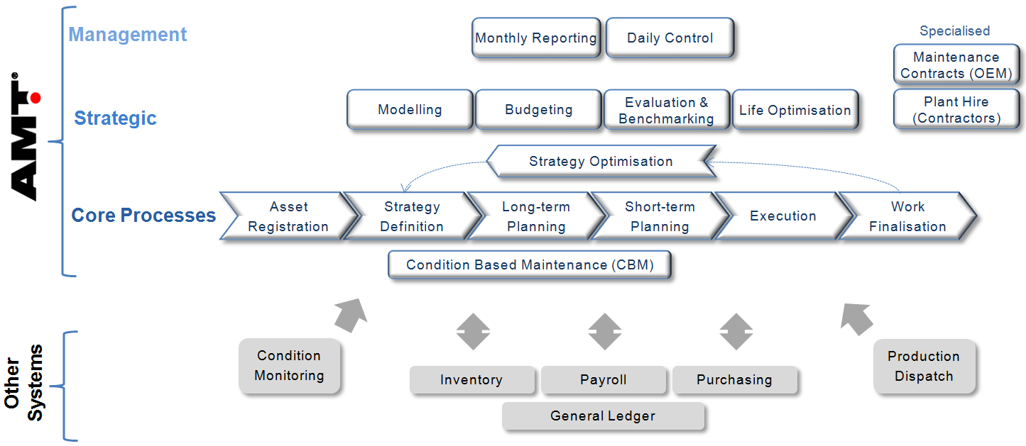

The AMT Core Processes encapsulate all the daily, weekly and monthly processes in the management of the Equipment. The AMT software provides an easy to use Graphical and Intuitive User Interface for these core processes. It is at this level that AMT has the main integration points to other systems.
Core Processes
Asset Registration | Allows organisations to maintain a central consolidated register of all assets – fixed and mobile plant, vehicles, etc
Strategy Definition | Define the base maintenance strategy which drives the maintenance program and life cycle cost engine.  - Standard Jobs system (can import from Builder)  - Attach Job Instructions  - RCM module for comprehensive strategy definition
Long-term Planning | Component management. Forecast availability, productivity, costs, components, Parts and labour requirements. Standard Job Management and Job Instructions
Short-term Planning | Backlog management, PM and Inspections control, daily planning and scheduling, Job Folder creation, raising POs’ and resource levelling
Execution | Service tool – electronic shift log, quick access to equipment history and component status, downtime capture and analysis
Work Finalisation | Capture job information including failure codes, condition monitoring data, attach documents and component tracking information
Condition Based Maintenance | Imports and interprets condition monitoring data, triggers creation of workorders and emails, monitors actions, displays “fleet condition”. Consolidates condition monitoring data from all sources. Drives both strategy and daily responses.
Strategy Optimisation | Feedback loop enable an accurate and optimum maintenance strategy. Routines to define and optimise maintenance strategies  - identify risk areas, play “what-if”, view fleet performance, evaluate changes to the strategy  - Validation - highlight inaccurate assumptions or standard jobs  - Component management - Maintain technical information on component performance and analyse component performance (ie “bell-curve”, analysis of failure modes etc)  - Product Problem Tracking - Log of all equipment issues and the steps to resolve them. Provides a knowledge database for future reference

The data structure inherent in AMT enables high level reporting as a direct output of the performance of the Core AMT Asset management Processes.
Strategic
Modelling | Maintain centreline (baseline) life-cycle templates for equipment. Model fleet scenarios. Used for analysing and comparing different tender or bid options – costs and productivity. Can include overhead costs. Calculate and evaluate contract tenders for MARC, CSA, PM and TM&Rs’  Model contract extensions
Budgeting | Specialised module to streamline the creation and maintenance of accounting budgets and forecasts. Can maintain multiple versions, export to corporate budgeting systems and perform analyses against actual performance.
Evaluation & Benchmarking | Evaluating and benchmarking equipment using routines such as life-cycle costing, Cost per Tonne and Discounted cash Flows
Life Optimisation | Forecasting optimal points to scrap/replace equipment
Management
Monthly Reporting | Comprehensive reporting covering:  - Financial Reporting – Costs vs Budget, Cost Analysis, Cost forecasting  - Equipment Performance – Availability and Reliability  - Maintenance Efficiency - ie Scheduling accuracy, Backlog ratios etc  - AMT IC (Intelligence Centre) enables consolidation of data and customized report writing.
Daily Control | Dashboard - Real time reporting of management KPIs in a graphical format, Quick-watch forms to display ‘exception’ transactions, Message board to display alerts
Specialised
Maintenance Contracts | Advanced functionality for tracking and measuring the performance of maintenance contracts – profitability, termination, cash flow and maintenance accrual requirements. Supports all types of contracts
Plant Hire/Rental | Advanced functionality for setting up, tracking and measuring the performance of plant hire/rental assets – profitability, cash flow and component based depreciation

Asset Life Cycle Costing
AMT is an Asset Management solution that measures real time asset performance giving Contract and Fleet Managers a suite of tools on which to base maintenance decisions. AMT creates Maintenance Projections (lists of maintenance tasks) for each asset to forecast the future maintenance costs for an asset over its useful life. Specifically, the core of AMT:-
- Reports life cycle costs of an asset in real time
- Reflects the current maintenance strategy
- Continually measures maintenance performance against budget and billings
- Determines optimum replacement life for components and assets
- Drives a proactive maintenance management approach
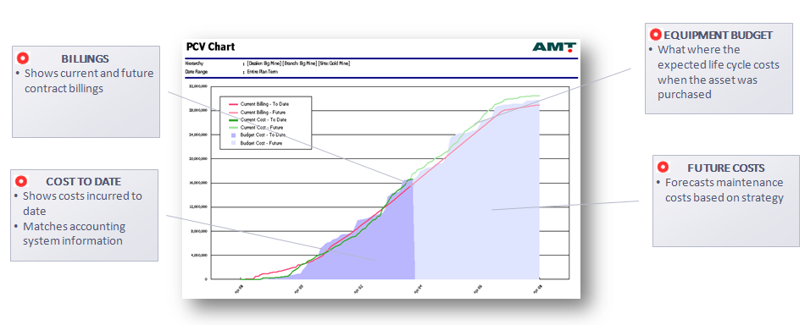
Once the ‘Maintenance Projection’ methodology has been established for each asset, AMT then provides many other useful Asset Management functions.
- Maintenance strategy analysis and optimisation
- Component planning and forecasting
- Component life tracking
- Task planning and scheduling
- Labour planning and forecasting
- Usage analysis
- Down time analysis
- Maintenance KPI reporting
- Contract Financial reporting
- Work order management and interrogation

Base Principles

- Supports Best Practices The first step in the design of AMT was to build the Framework that is a best practices tool that maps out and defines equipment management best practice. AMT has been developed to support those processes.

- Life-cycle costing AMT projects full life-cycle costs and productivity for assets (unlimited term) and maintains a full equipment history database.

- Multiple Projections Multiple projections (maintenance strategies) can be maintained for equipment to maintain records of original assumptions, take a snapshot at a certain time and to “play what-if” with different scenarios. These Projections can be based on different severity profiles.

- Escalation AMT automatically adjusts Projections for escalation and applies different methodologies based on the analyses being performed.

- RCM Principles AMT supports RCM principles. Probabilities of failure modes are incorporated into future projections and provides analyses of historical performance against original RCM assumptions

- All asset related costs All asset related costs can be captured/processed and forecast in AMT to provide a complete set of data for analyses. This includes Work orders, other equipment specific operating costs not normally captured on such as finance and fuel consumption and site overheads – produces 100% of an operating budget.

- Real time AMT is a dynamic, real-time program (no waiting for overnight routines)

- Single integrated database AMT draws on one database – no duplication of system tables or data entry

- Configurable The modular construction means AMT can be configured to meet a specific customers’ needs – modules turned on/off. AMT can be deployed on a server or on an individual’s PC.

AMT Modules

AMT Modules detailed below include:
- Core Processes
  - Asset Registration
  - Strategy Definition
    - Centrelines
    - Standard Jobs
    - Document Library
  - Long-term Planning
    - Parts Forecasting
    - Rotables
  - Short Term Planning
  - Execution
  - Work Finalisation
    - Workorder System
    - Parts Usage and Warranty Analysis
  - Strategy Optimisation
    - Component Management
    - Equipment Management Issues
  - Condition Based Maintenance

- Strategic
  - Modelling
    - Sales Tool (Contract Rate Calculator)
  - Budgeting
  - Evaluation & Benchmarking
  - Life Optimisation

- Management
  - Monthly Reporting
    - Equipment Performance Reporting
    - Maintenance Efficiency Reporting
    - Financial Reporting
    - AMT IC (Intelligence Centre)
  - Daily Control
    - Dashboard
    - Quick Watch

- Specialised
  - Maintenance Contract (OEM)
  - Plant Hire (Contractors)

Core Processes Asset Registration
A central consolidated asset register – improved control
Allows organisations to maintain a central consolidated register of all assets – fixed and mobile plant, vehicles, etc
Technical details on the assets, their purchase and disposal can be recorded. Depreciation schedules can be setup, monitored and amended over time. Depreciation transactions can be generated and automatically posted to your accounting system.
AMT also supports Condition Based Depreciation (CBD) where major components are depreciated based on their estimated lives and utilisation. When they are repaired/replaced the cost is not expensed rather it is ‘paid for’ out of the accumulated depreciation. This has three big benefits – more accurate asset valuation, more accurate costing of asset utilisation and smoothes the repairs and maintenance expense.
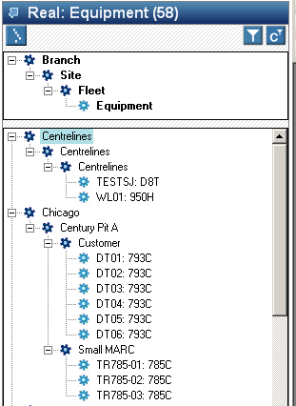
Central listing of all assets – graphical navigation
Record technical details on equipment
Record purchase and disposal details
Calculate depreciation rates
- Calendar based
- Utilisation based rates (hours, fuel burn, travel, kms etc.)
Condition Based Depreciation
Process monthly depreciation
Can setup and process other asset specific costs such as finance and insurance
Automatically post transactions to accounting systems
Evaluation of book value vs calculated market value
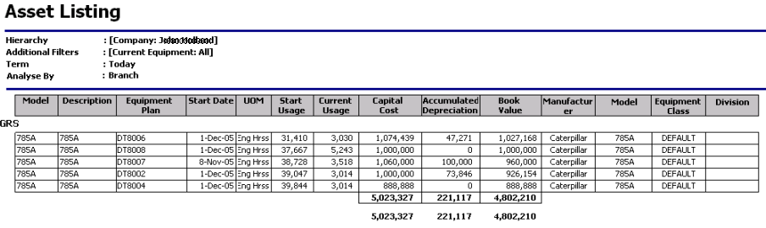

Core Processes Strategy Definition
Consolidate the Equipment Management
Define and Set Best Practices
The Maintenance Strategy for an Asset contains the latest Equipment management and Life Cycle costing information. The Strategy is the basis for the achieving Best Practice management of the equipment.
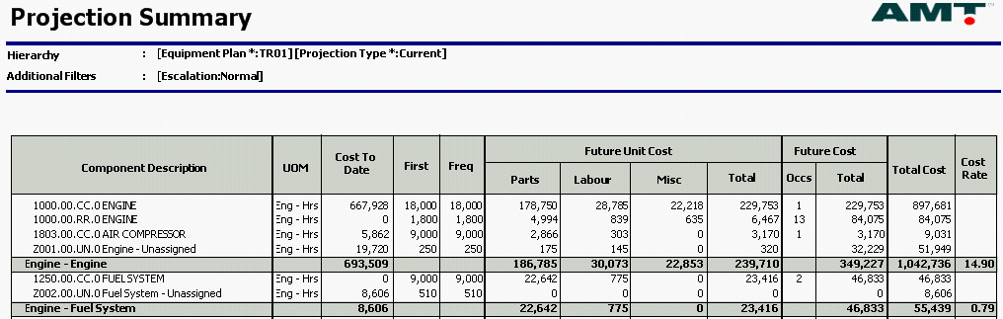
The Maintenance Strategy comprises of all the elements to consolidate the Management of the Equipment:
- Coding is critical in the identification of each Strategy item.
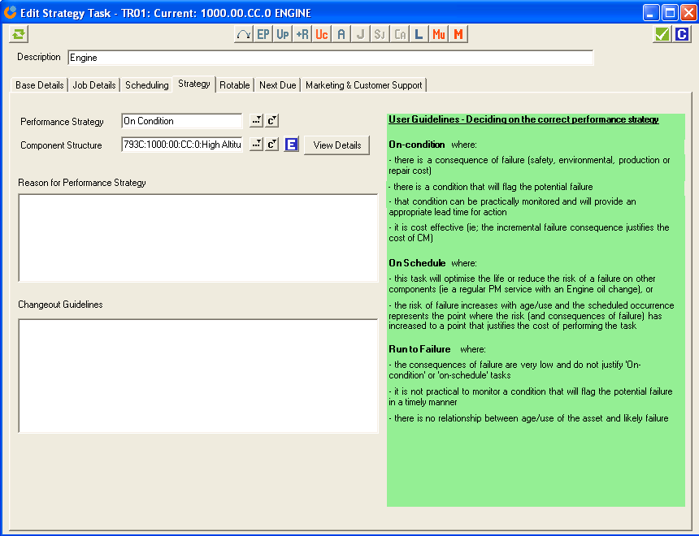
- Strategy items include Services, Inspections, Planned Components, non planned components and provision for unassigned. And includes both the schedule and cost of repair.
- Advanced PM and Pre PM Inspection Schedules can be set up.
- Set up Major Risk Component schedules and the actions to mitigate Component Failure.
- Set the Strategy to perform each component
  - After Failure (where difficult to determine or the consequence of failure is low)
  - On Schedule (PM Services)
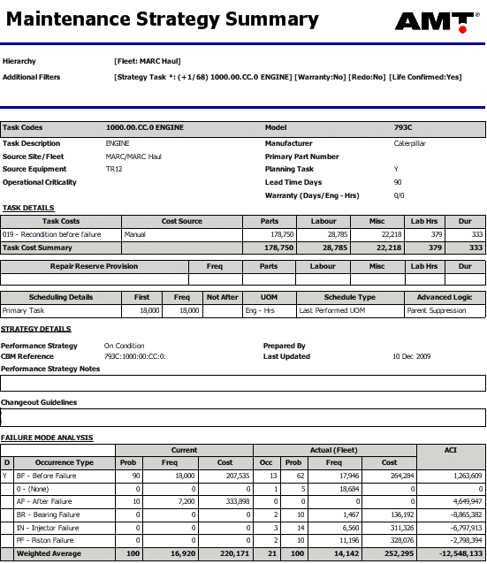
  - On Condition (most major components)
- Standard jobs can be associated to each component for parts, labour and other requirements
- Library documents can be associated for Job, Safety and other instructions
- All cost items (including a provision for unassigned repairs) can be provided to build up a life cycle estimate cost.
- Costs can be coded to relevant Cost Centres or Expense Elements.
- Labour can be categorised by Work Group or labour Activity
- The base strategy definition can be set up as a template (centreline).
- Advanced editing functionality , including interfaces and multi-editing
- Can create multiple strategies, ie Base “Budget“, “What-If” or “Archive”
- Detailed Strategy Review documentation assists in the structured review of major components and the Assets Maintenance Strategy.

Core Processes Strategy Definition Centrelines
- Baseline life-cycle templates |  | - Standardisation  - Streamlined processes

The Centerline functionality allows users to setup life-cycle templates for equipment. These are in the same format as the real equipment projections (budgets). The centerlines can be copied to rapidly register new contract equipment.
The Centerline module streamlines the processes for Modelling and registering new Equipment (provides the starting point for new assets)
Drives standardisation - all equipment has the same basic structure for its maintenance strategy.
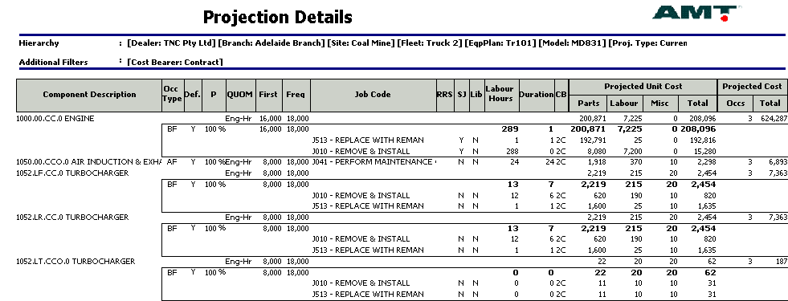
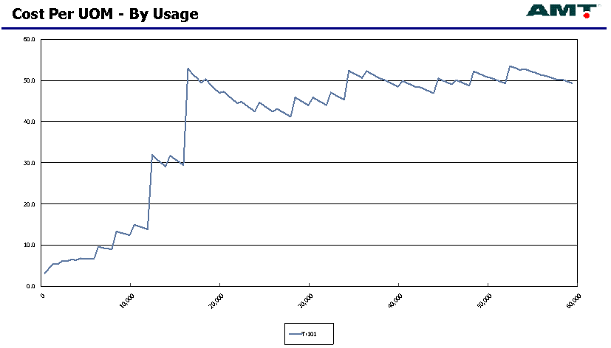
- Flexible editing and analysis
- Can use real equipment history to create Centrelines
- Can create Centrelines from Standard Jobs (can import Standard Jobs from other systems)

Core Processes Strategy Definition Standard Jobs
Driving quality, consistency and efficiency
Ability to maintain standard jobs for selected tasks that detail the operations to perform the tasks and their respective labour and parts requirements.
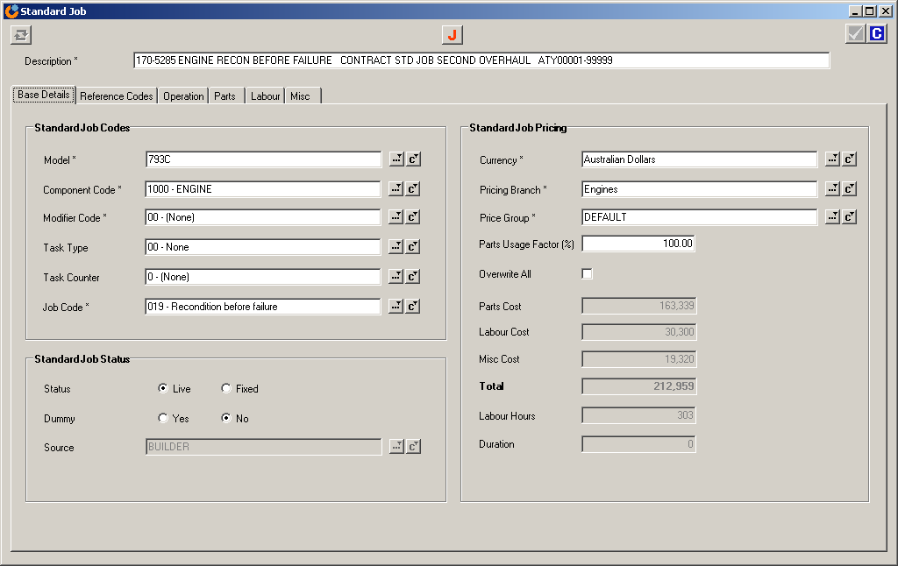
- Single database supports Centrelines, Modelling, Strategy, Planning and Parts Forecasting
- Flexible coding structure
- Can copy, edit and elect to over-ride calculated totals
- Can archive standard jobs (ie to support Modelling)
- Can price standard jobs based on branch location and customer profile
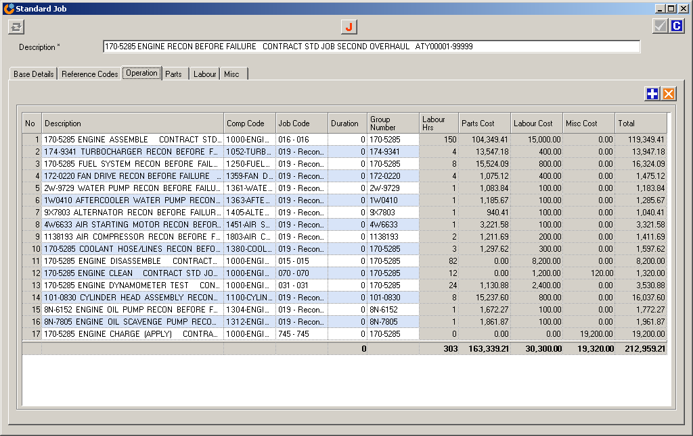
- Accommodates probability of parts usage
- Can import standard jobs from ERP or other systems
- Can replicate ERP standard jobs (ie have ERP as the master)
- Can export standard jobs
- Routines to update for superceded parts
- Parts pricing update routines
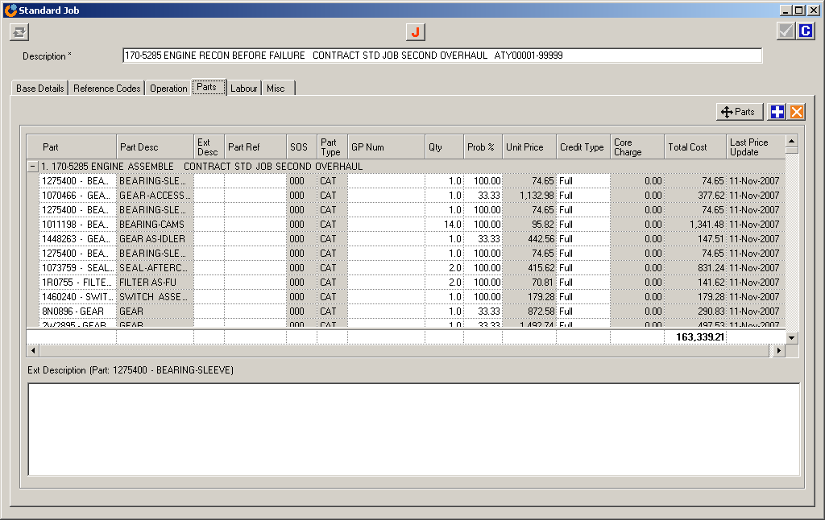
- Can create strategy tasks from standard jobs
  - Supports process of:
  - Standard Jobs – Modeling – Real Equipment in AMT
- Supports parts forecasting process
- Quality measure - % of work covered by standard jobs

Core Processes Strategy Definition Document Library
- Document Control  - Standardisation  - Information Sharing |  | - Improved Quality  - Improved Efficiency

A central web based depository for all equipment management documents.

Leads to information sharing and standardisation
Avoids people re-inventing the wheel to recreate documents that already exist
Can store any file types (Word, Excel, etc)
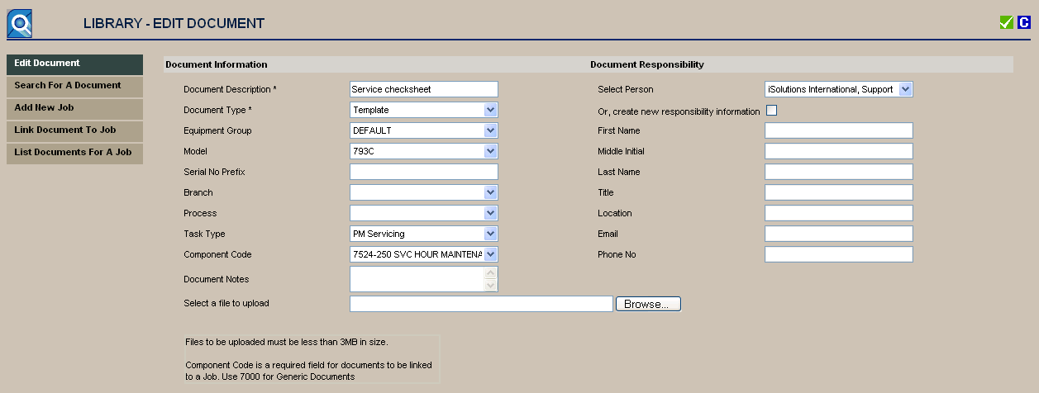
Can be stored by document type
- Work scopes (Job instructions)
- Inspections
- Safety checks
- Position descriptions
- Best practice information
- AMT guidelines
- Corporate policies and standards
- Commercial agreements
Can group documents required for specific jobs
- Integrated to Strategy & Planning
- System will flag to users if there are supporting documents in the Library for that task
User can automatically preview and print the documents from Strategy & Planning
Simple routines to add or remove documents
Security levels determine who can access and/or edit documents

Core Processes Long Term Planning
- Cash Flow Forecasting  - Component Forecasting  - Labour Planning |  | - Optimise Resources  - Improved Availability

Allows users to forecast the labour, parts and cash flow requirements.
The forecast is driven by the maintenance strategy.

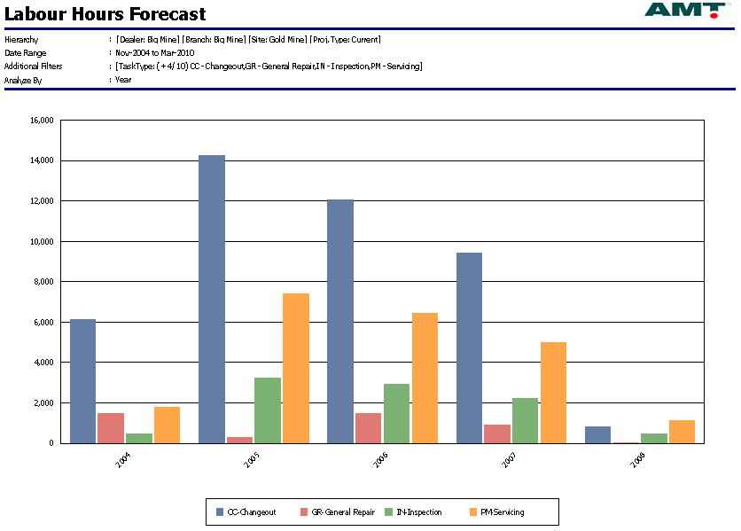
Labour
- Forecast planned labour hours
- Forecast total labour head requirements (new improved calculation currently being added)

Components
- Forecast component requirements
- Forecast by component code and part #

Cash flow
- Forecast monthly costs
- Can analyse by machine, task type etc
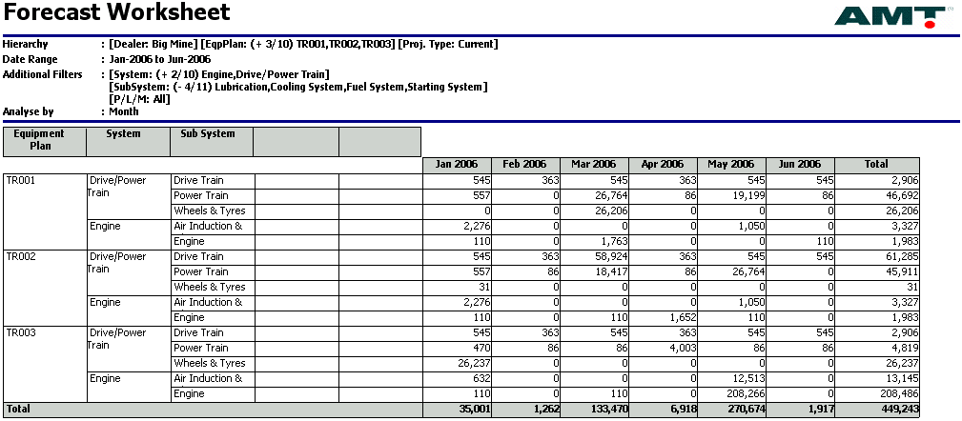

Core Processes Long Term Planning Parts Forecasting
Parts for Component changeouts are based on forecast not history

Parts Forecasting, by combining the planned schedule of work from AMT Analyzer with the Bill of Materials in the Standard jobs for those Tasks, the system produces a forecast of parts requirements. The Standard jobs can either be maintained in AMT or the ERP Standard jobs can be replicated into AMT (the latter being the suggested approach). Parts Forecast reports can then be viewed or exported electronically to the ERP system’s inventory management module.

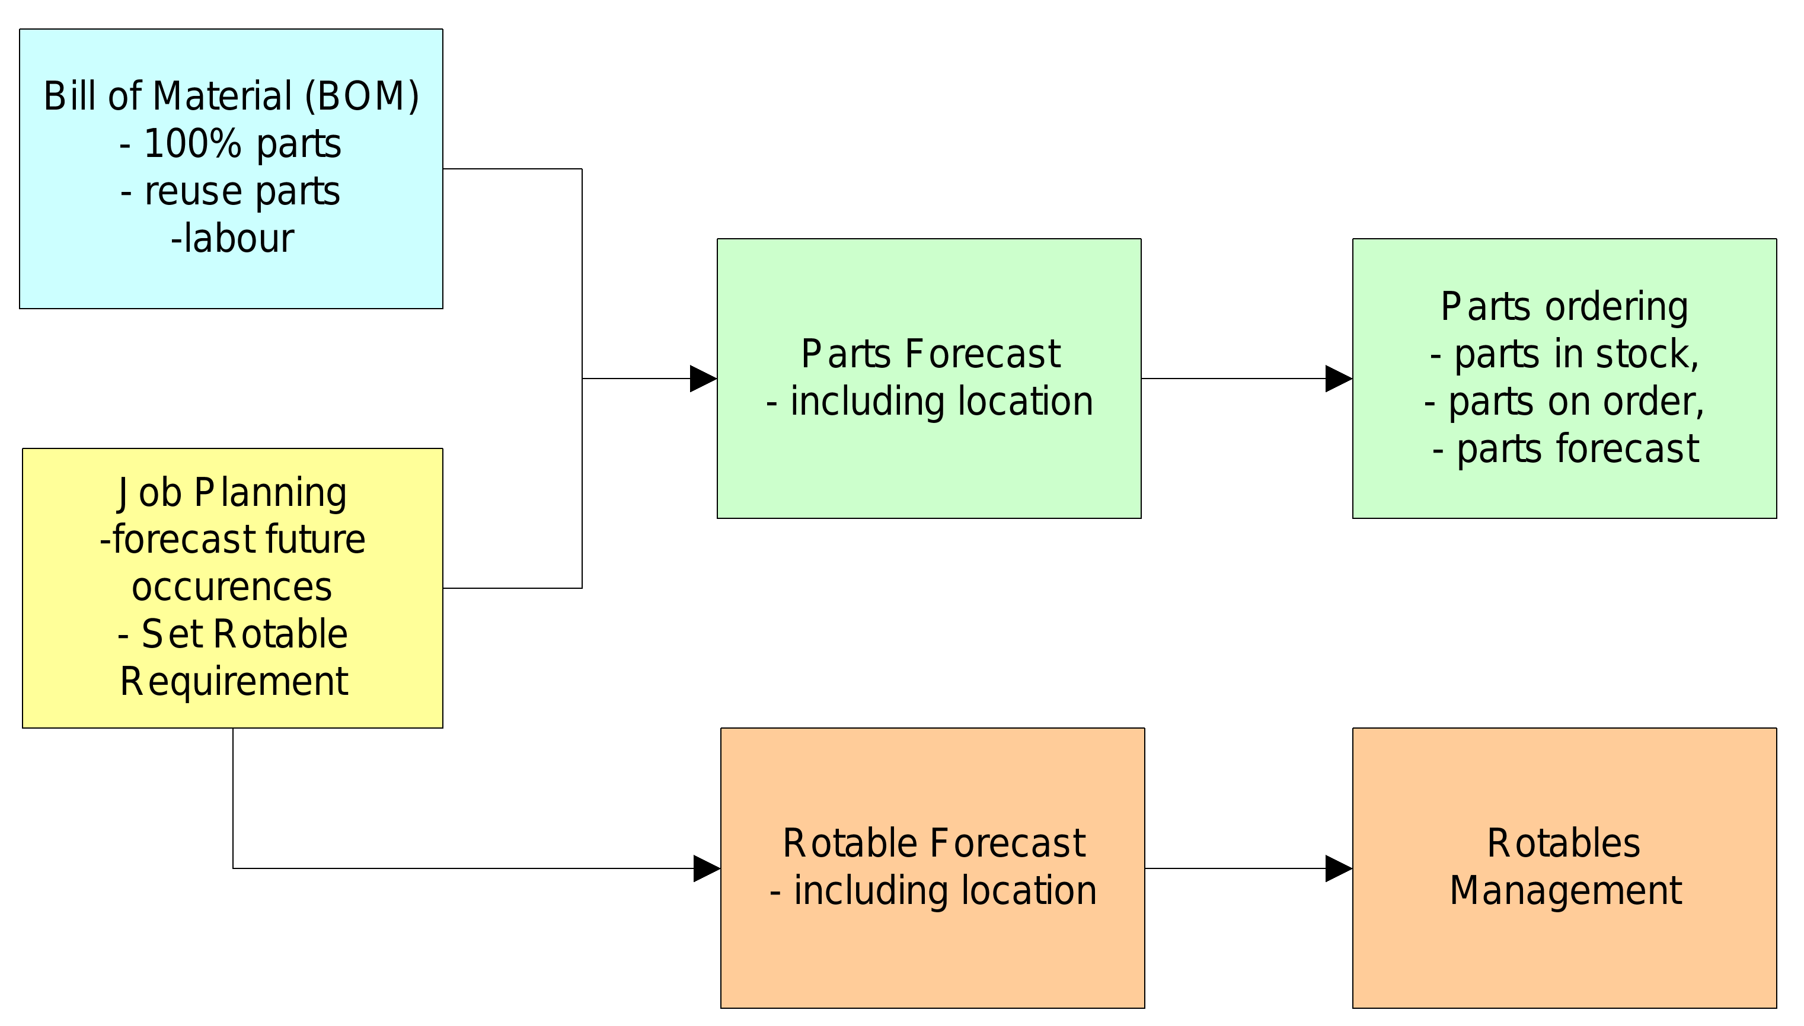

The first step in setting up the parts forecast is to have an accurate set of parts requirements. The parts list and standard jobs master copies are typically maintained in an ERP system or in AMT’s Standard Job module.

Core Processes Long Term Planning Rotables
Track High Value Serialised Components
The AMT Rotables module tracks high value, rotable components. It follows a structured management process to tightly control and track the status of components throughout their lives.

- Full component history tracking
  - You can quickly see the status of all rotables. The program tracks rotables by both status and location. Also shows installed components
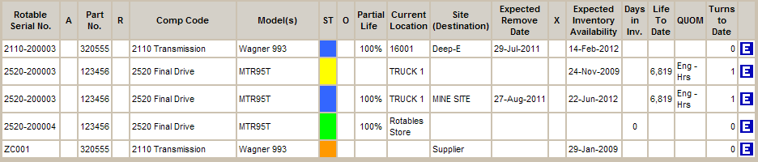
- Individual serialized components
- Tracking by status and location
- Tightly integrated to the maintenance system
- Alert to low stock condition
- Flexible reporting on stock levels, number of rebuilds, stock turn etc.
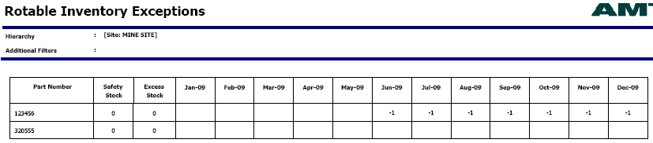

Core Processes Short Term Planning
- Backlog Management  - Resource Scheduling  - Job Ready Planning |  | - Work Quality  - Planning Compliance  - Efficient Operations

Provides users with a streamlined, easy to use daily planning and schedulinf system. With integration to Strategy, Standard Jobs, Library, Equipment Status and Work Orders it is a powerful and efficient tool.

- Integrated to component changeout schedule
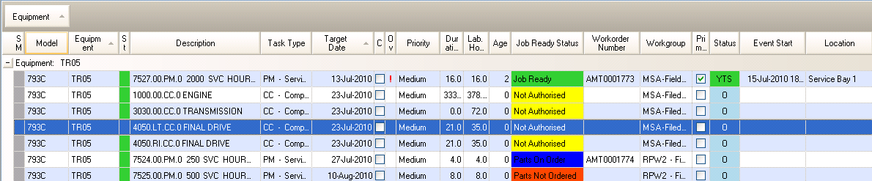
- Record backlogs (defects) – technical and planning information
- Flexible analysis and grouping of workorders to be performed
- Task type (ie PM services), Equipment, Priority etc
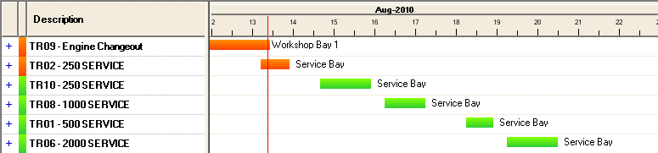
- Workorders linked to Standard jobs
- Workorders linked to Workscopes (Job instructions, JSA, Inspection sheets, ect) Integration to ERP
- Create planned events with many workorders for each event
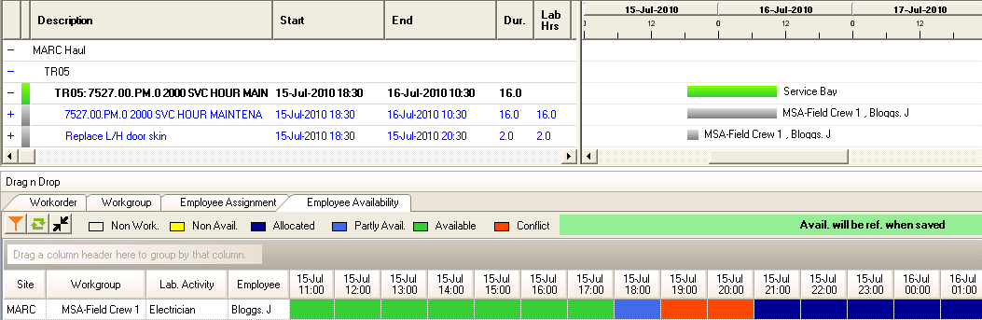
- Scheduling of workorders and resources within events
- Shutdown scheduling enabling workorders from many equipment to be grouped and scheduled.
- Perform labour resource smoothing at an employee or workgroup level
- Produce daily work plans and detailed job folders
- Raise purchase orders directly from AMT
- Flag if workbays are available
- Automatically open workorders in ERP
- Status of tasks automatically updated from Equipment Status

Core Processes Execution
- ‘Real Time’ Shift Log  - Integrates to Dispatch Systems  - Set Delay Responsibility |  | - Streamline Processes  - Identify Delay Causes

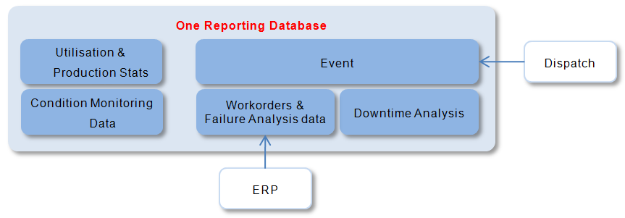
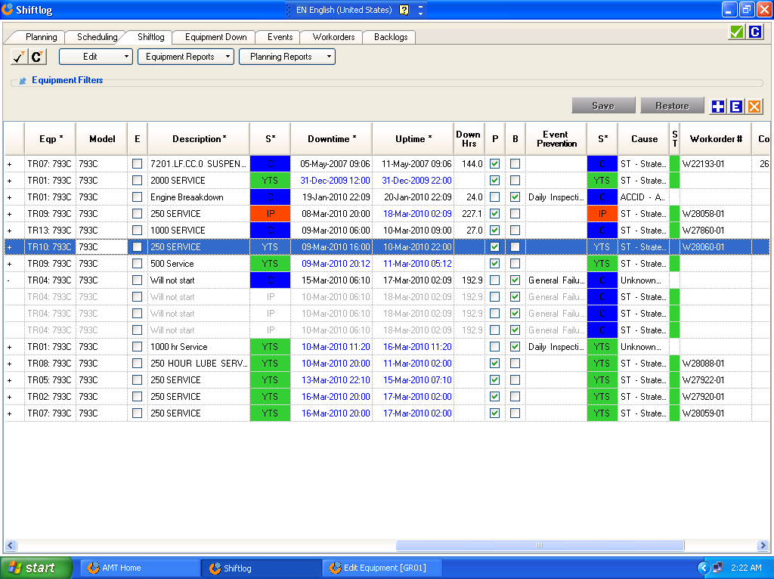
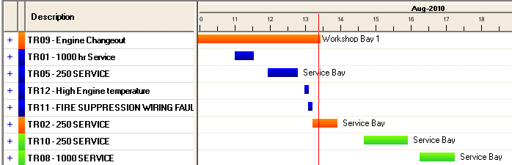
Equipment Status is the “service” tool. It provides a real time electronic shift log where users can view the work plans, be alerted to breakdowns, access relevant equipment history and component status information, capture downtime and technical information about the job, create work orders, update work plans and produce daily reports.
The result is a practical tool that
- does away with whiteboards
- streamlines breakdown work order creation
- provides quick access to relevant history and planning data from one screen
- streamlines the capture of downtime and technical data
- creates one consolidated reporting and analytics database
- Can be integrated to Dispatch to receive downtime Events
- Can be integrated to ERPs’ to create Workorders
- It is the glue that connects ERPs and Production systems
- Graphical display - status of equipment and work plans
- Easy to use format – no navigating through multiple menus
- Consolidated database for reporting – costs/downtime/technical information
- Categorises multiple downtime causes for a single downtime event.

Core Processes Work Finalisation
Ensure Accurate Data used for Reporting and Analysis

This critical step in the process ensures that the AMT Data is accurate for Reporting and Analysis. The AMT Life Cycle Costing engine requires accurate data, and KPI reporting similarly requires accurate and complete data. Although the processes are designed to maximise the accuracy of the data through each step of the process the work finalisation step is a critical final stage.

Events and Workorders
- Are the downtime details correct
- Were all the delays correctly entered
- Was all the work performed
- Have parts been returned
- Were there any serialised component changeout details
- Is there potential Warranty on the work performed – utilise the AMT Parts Usage and Warranty Functionality

Completed Job Folders
- Are all job details entered, Symptom, Cause, Repair
- Are important documents attached to the workorder, ie failure photographs

Measurements entered

- Are all condition monitoring or consumption measurements entered

Defects Captured

- Have any defects noted during the event been captured and entered as backlogs.

Quality Audit/ Continuous Improvement

- Was the work performed correct?
- Were there any lessons to be learned?
- Do existing instructions need to be changed?

Core Processes Work Finalisation Workorder System
Accuracy and Efficiency
Proven Integration

AMT has full work order functionality where users can create Work orders and capture costs and settlements directly into AMT. Alternatively work orders can be managed in another system and raised from within AMT. Final work order costs can then be imported into AMT.

- Integrated to Daily Planning
- Flexible coding structure
- Can import Standard Job details – parts and labour requirements
- Can create “Requests for Quotes” (print out or email directly to suppliers)
- Can create “Purchase Orders” (print out or email directly to suppliers)
- Capture parts usage and parts costs (by part #)
- Capture labour hours and cost by labour category and/or employee
- Capture miscellaneous costs (includes sub-contract/outwork)
- Apply settlement rules – split the costs of a workorder over a number of accounts
- Can send accounting entries to ERP
- Can link to downtime information for analyses
- Can link to technical information for analyses (failure modes, etc)
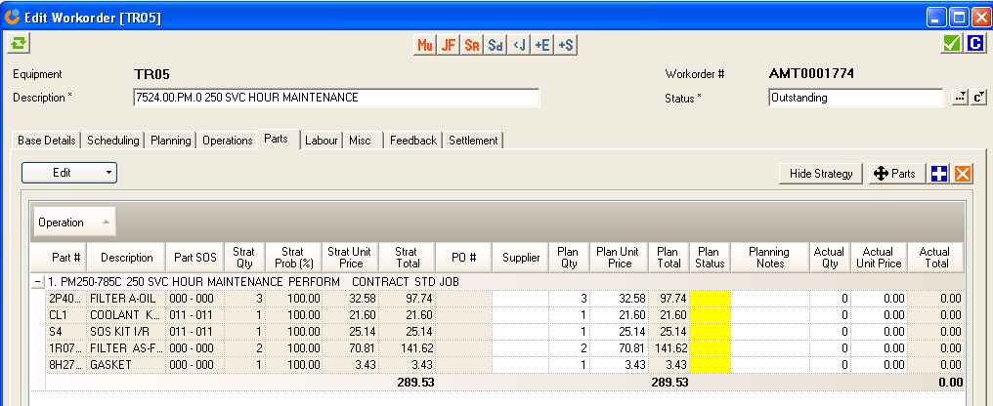

Note
If an organisation has an existing WO system (ie SAP/Ellipse/JDE) then AMT can be configured to integrate with this system - AMT can initiate the creation of the WO within that system and import WO summary information from that system.

Core Processes Work Finalisation Parts Usage & Warranty Analysis
Analyse Parts used for Repetitive Jobs
Use as a source for Building Standard Jobs
Quickly identify Potential Warranty Workorders
Parts consumption generally accounts for 60-80% of asset repair and maintenance costs. The Parts Usage & Warranty Analysis module supports continuous improvement processes and allows organizations to analyse parts usage to identify performance issues and warranty, evaluate inventory requirements and improve standard jobs. The benefits are

- Identify product issues
  - Identify the high usage parts
  - Can filter by component code, breakdowns
- Improved inventory
  - Review historical usage to evaluate future inventory requirements
- Lower emergency orders and parts returns
  - Improved standard jobs by being able to evaluate the parts usage for regularly performed jobs
- Identify potential warranty
  - Ability to nominate warranty groupings, each with specific warranty periods
  - Compare frequency of parts used within the warranty period of specific warranty categories/groupings

Core Processes Strategy Optimisation
- Life Cycle Costing  - Identify Risk / Opportunities  - Be Smarter … |  | - Improve Profitability  - Reduce Costs

Allows users to view the life-cycle costs for equipment against centerline budgets/templates and apply methodologies to set the maintenance strategies that optimise performance, costs and resources.

Life Cycle Costing
- At the component level
- Can be integrated to ERP Maintenance Plans
- Incorporates actual and projected future costs
- Reflects all equipment costs (not just planned tasks)
- Incorporates failure modes and related probabilities
- Can be supported by Standard Jobs
- Feeds into planning process
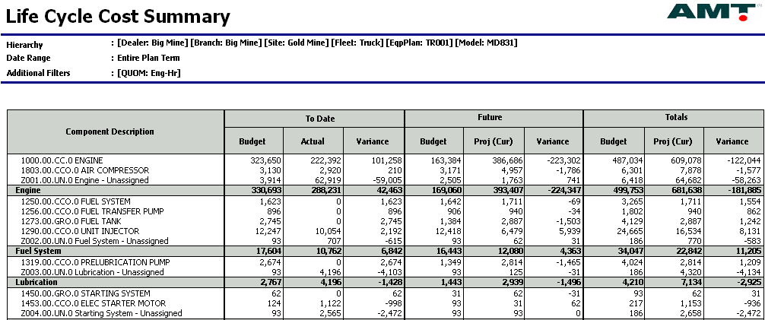

Cost analysis
- Detailed and flexible cost analysis
- Can be analysed by component, model, fleet, site etc

Risk management
- Variance analysis against life-cycle templates - Costs to date & Projected future costs
- Component residual value risk/opportunity highlighted
- Unrealistic productivity forecasts highlighted
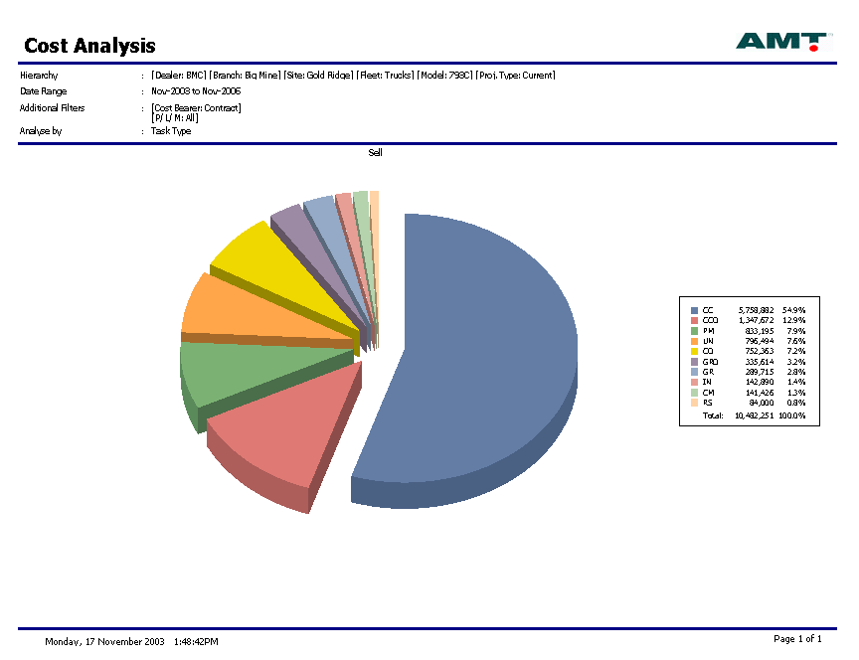
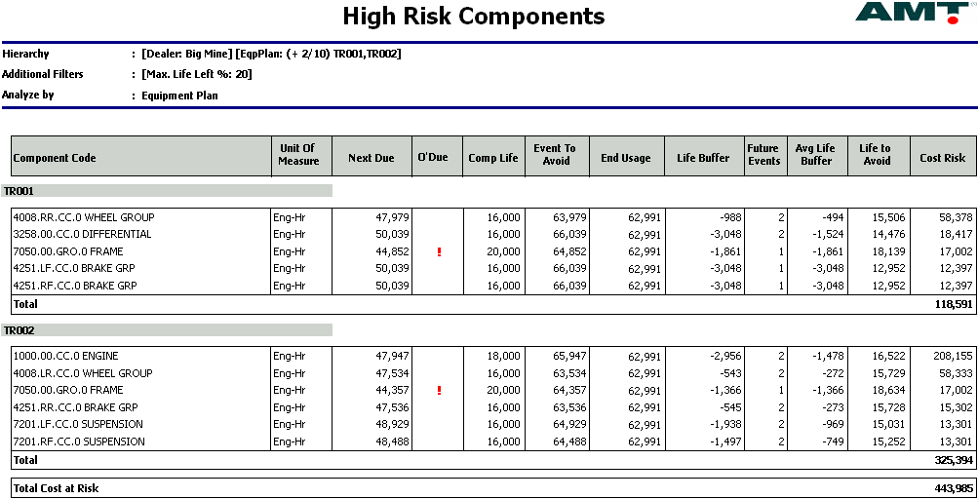

Maintenance strategy optimisation
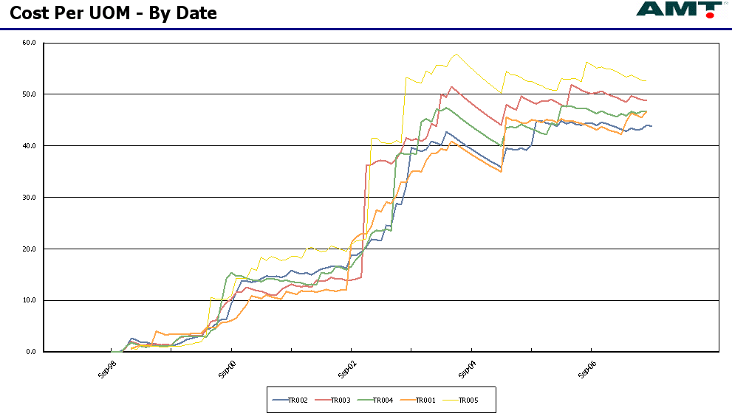
- Life-cycle impact of maintenance strategy quantified
- Evaluate impact of changes
- Recognises impact of different failure modes
- Can edit the strategy at a fleet level
- Automatically update ERP Maintenance Plans

What-if analyses
- Can save and manipulate multiple versions of strategies
- Can play ‘what-if’ to assess different strategies
- Can benchmark different strategies

Core Processes Strategy Optimisation Component Management
Component lives are the biggest driver of Maintenance Costs

Enables users to optimise and set their component change out schedules for the next 3-12 months. Users can perform technical analyses on historical change outs to identify failure modes, causes of failure etc to identify the risks, improvement opportunities and the optimal change out points. Graphical screens allow users to easily update the next change out, align a change out with other tasks required for that equipment and ensure the overall workload is “smoothed”.
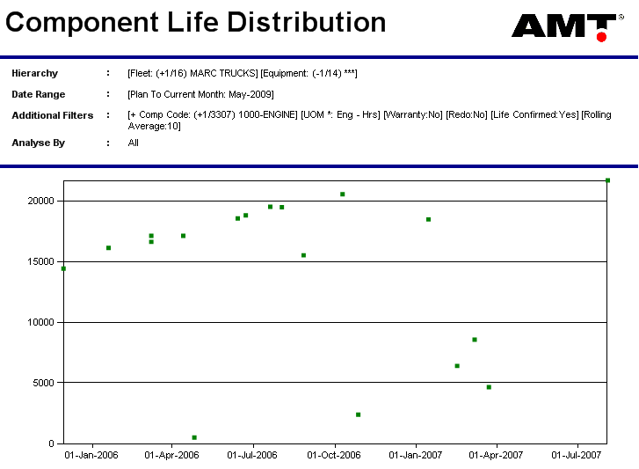
Component Performance Analysis
- “Bell-curve” analyses
- Record technical details on change outs
- (failure mode, Part # that failed, symptoms repair action etc)
- Technical analyses of historical change outs
- Drill down to work orders

Component Change Out schedule
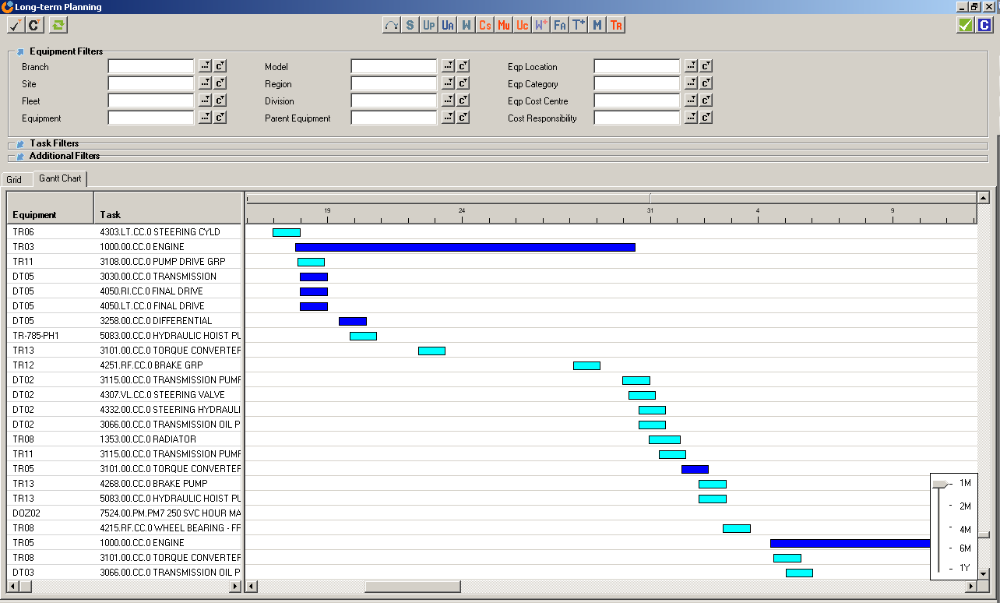
- All scheduled items due within a “planning window” automatically flagged to users
- Graphical view
- Users can click and drag items
- View/sort by equipment to align tasks for that equipment
- Can view by component code to smooth machine stoppages etc
- Can print out change out schedule
- Feeds into daily planning system

Core Processes Strategy Optimisation EM Issues
Consolidate Management of Product Problems.

“EM Issues” stands for “Equipment Management Issues” and covers all issues directly related to an equipment type/model. Issues include Product Problems (Equipment Design, Equipment Manufacture), OEM updates, Continuous Improvement initiatives, significant Application and Operation issues, poor Maintenance Practices (redo, inappropriate Workscopes etc), and general performance items that need to be addressed.

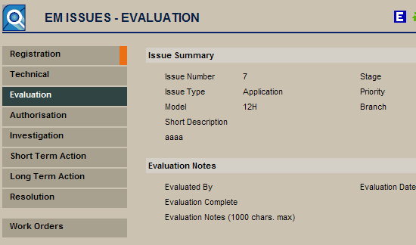
AMT provides a structured process to log and manage product problems. Builds a valuable knowledge database that can be shared across your company.
- Log product problems
- Defined resolution process
- Attach related documents
- Define short-term and long-term corrective action
- Share across the organization
- Quantify the impact of the issue (cost/downtime)
- Processes to Fix the Issue

Core Processes Condition Based Maintenance (CBM)
Drive Component and Maintenance planning based on Condition

CBM is the process of interpreting Condition Monitoring data against reliability assumptions to optimize maintenance decisions. Integrate Reliability Centred Maintenance (RCM) into your daily practices. Define a RCM structure against key components, interpret Conditioning Monitoring data against the RCM structure and trigger maintenance actions and track/code failures for reliability analyses.

- Reduce number of components replaced after failure
- Collect component failure information against the equipment plan/strategy
- Optimise component change-outs based upon equipment health
- Define maintenance strategies using an RCM methodology
- Full integration of RCM, Condition Monitoring and Long term and Short term planning.
- Trigger actions such as backlog Workorders, Messages (through the AMT Message Board) or Emails for urgent action.
Making the most of your CM data
Streamlining the interpretation process
Leveraging the IP in the organisation
Optimising maintenance decisions

Prevent failures
Optimise component lives

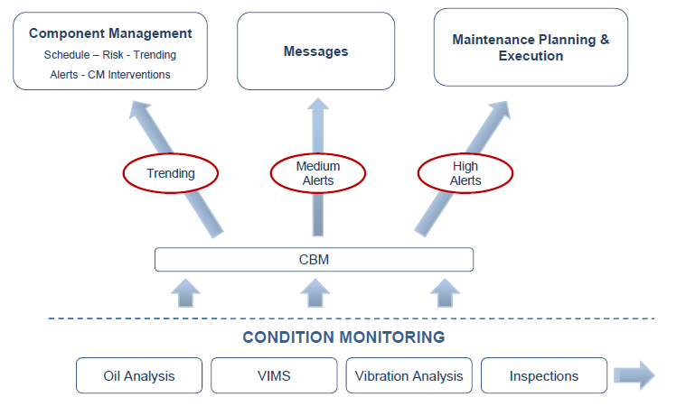
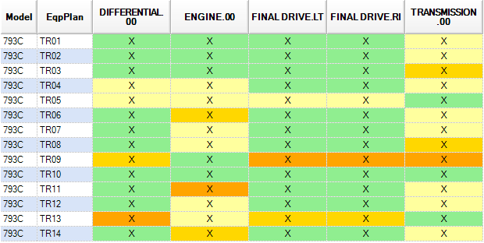

Strategic Modelling
- Develop Full Tender Scenarios  - Benchmark Scenarios |  | - Optimise Contract Costs

Modelling allows users to quickly prepare cost and productivity models for different fleets to evaluate budget and tender options. Tender scenarios are saved in the secure SQL Server database to provide a secure audit trail.
- Can import Centrelines or real equipment projections
- Flexible editing and analysis
- Different equipment start dates/terms etc
- Assess impact of changing site severities
- Maintain and analyse multiple versions
- Supported by Standard Jobs
- Cost analyses
- Financial evaluation
  - Cost per Hour
  - Cash Flows
  - Discounted Cash Flows
  - Discounted Cost per Hour
- Cash flow forecasts
- Forecast labour and components
- Identify optimal points to replace equipment
- Risk analysis

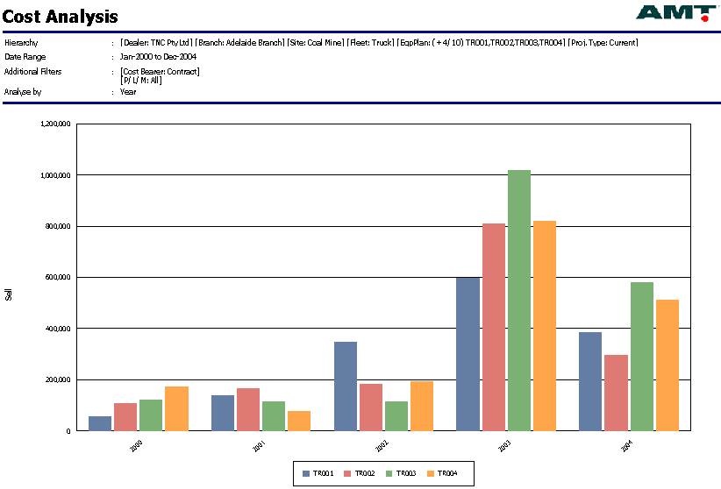

Strategic Modelling Sales Tool
Customer Agreements are the future for a Supplier
Give your sales personnel the tools to enter into these Agreements

The Sales tool provides a simple calculator for field personnel to provide an initial quote to a customer for a maintenance contract. The calculation is based on nominated Centrelines for different Equipment Models.
Quote functionality includes:
- Life cycle cost estimates
- Service Agreements with hourly, monthly or per service billing rates
- Maintenance Agreements
- Component Cost cap Agreements
Prices can be modified based on specific requirements:
- Nominated Labour Rates
- Travel Costs
- Fluid included/excluded and special fluid pricing
- Special Customer Pricing
- Customer Specific Inclusions/Exclusions
- Component Risk based on contract termination
Other special functionality:
- Easy to use for Sales Personnel
- Separate Sales Tool Log On.
- Track the status of agreements.
- Base pricing updated with modification of standard jobs or loading of new parts prices
- Authorisation Process that required internal authorisation before a customer quote is provided
- Backup of quotes provided to customers.
- Easy roll over from quote to managing equipment
- Identifies Contract Risk.
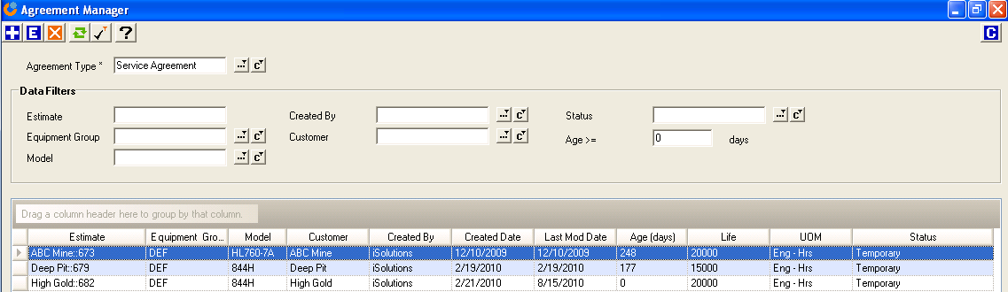

Strategic Budgeting
Zero Based Budgeting made easy!
Dynamic Life Cycle Costing Enables Budgets in Minutes

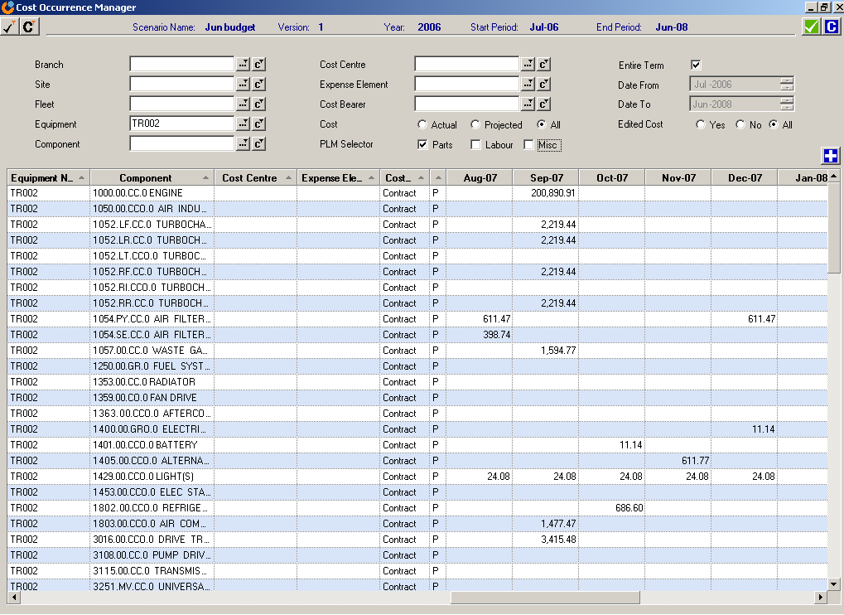
- Quick and simple to create … created in minutes!
- Supported by detailed maintenance strategies
- Covers 100% of maintenance costs – overheads & direct costs
- Covers productivity, OPEX, CAPEX, manpower and components
- Flexible “excel type” editing
- Ability to “play what-if” – maintain and compare multiple versions
- Future comparisons against actual costs
- Drill down on cost drivers
- Export to corporate budgeting systems

Covers - Operational Costs ; Capex ; Availability ; Utilisation ; Components ; Manpower
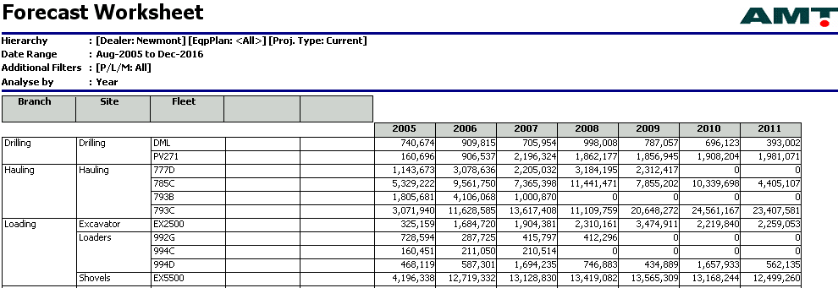

Strategic Evaluation & Benchmarking
Life cycle evaluation
Include Productivity and Availability
cle evaluation

Evaluating and benchmarking equipment using routines such as life-cycle costing, Cost per Tonne and Discounted cash Flows.
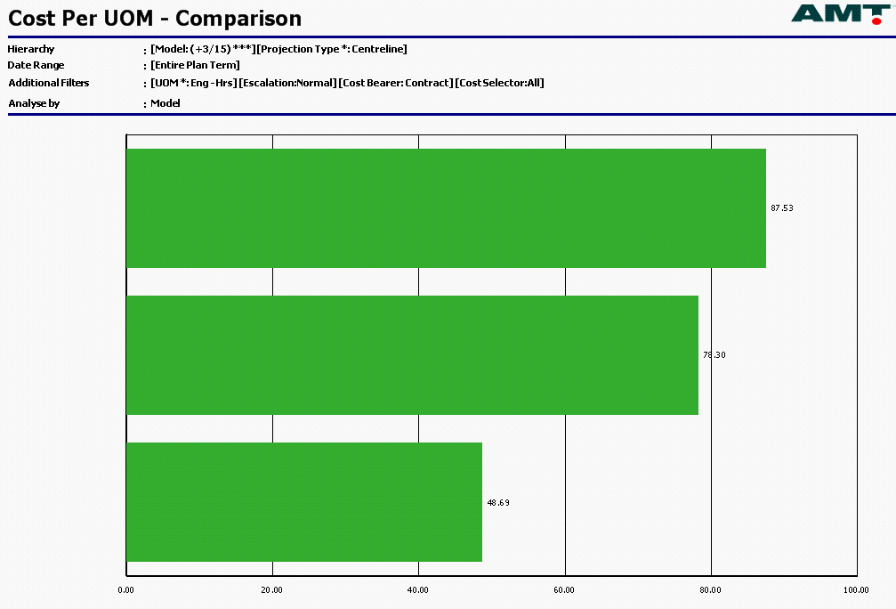
Benchmarking and evaluations include::
- comparing performance to “Best Practice”
- comparing performance to “Equipment Budget”
- comparing performance between equipment
- comparing one model of equipment to another
- comparing one mine plan to another

Areas for Evaluation and benchmarking include:
- Maintenance Cost
- Equipment Productivity
- Equipment Availability
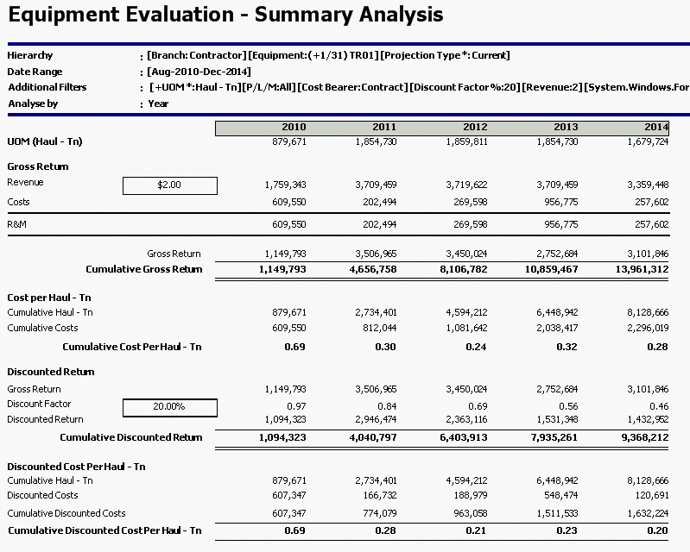
- Equipment Reliability (MTBF)
- Discounted Cash Flow
- Cost per tonne/km etc
- Overhead costs
- Labour and resource requirements
- Cost of lost production.

Strategic Life Optimisation
Optimise Equipment Termination Points

Asset Replacement planning is critical for Operational Performance and Asset Maintenance Costing. Dynamic Life Cycle costing in AMT provides the means to continuously determine the best time to terminate/replace Assets. It also identifies critical risk/opportunity components near the end of the Asset Life.

- Continuously forecast best time to terminate Assets
- RVIC “Residual Value in Components”. Plot the RVIC over time/life to optimise the replacement point.
- Identify “High Risk” components
- Identify “High Opportunity” Components
- Assist in component strategy – ie which components to install in which equipment near life end

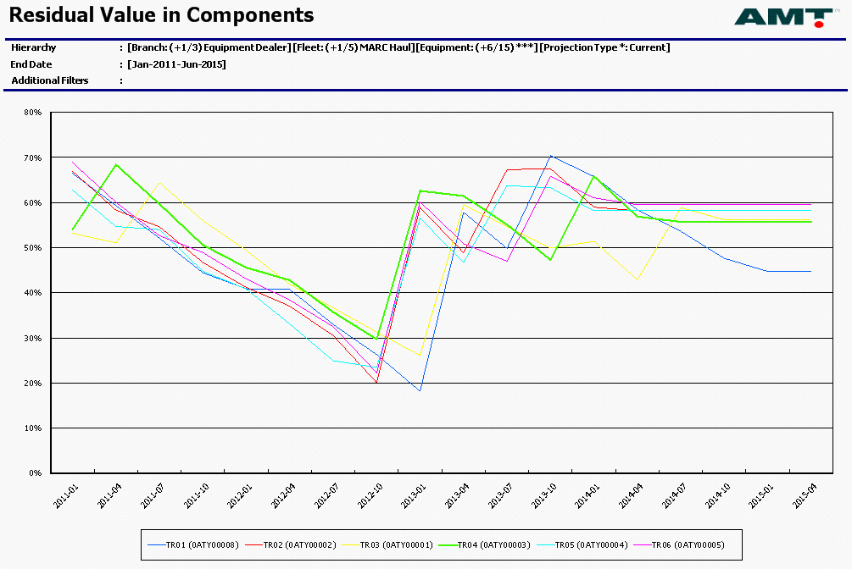

Management Monthly Reporting Equipment Performance Reporting
A standard set of industry KPIs and analytical tools
One consolidated database for reporting & analytics

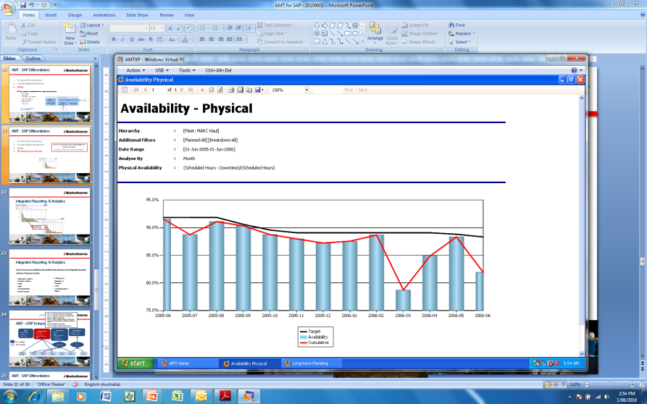
Availability
- Mechanical & Physical
- By responsibility and Downtime classification
Reliability
- MTBS / MTBF
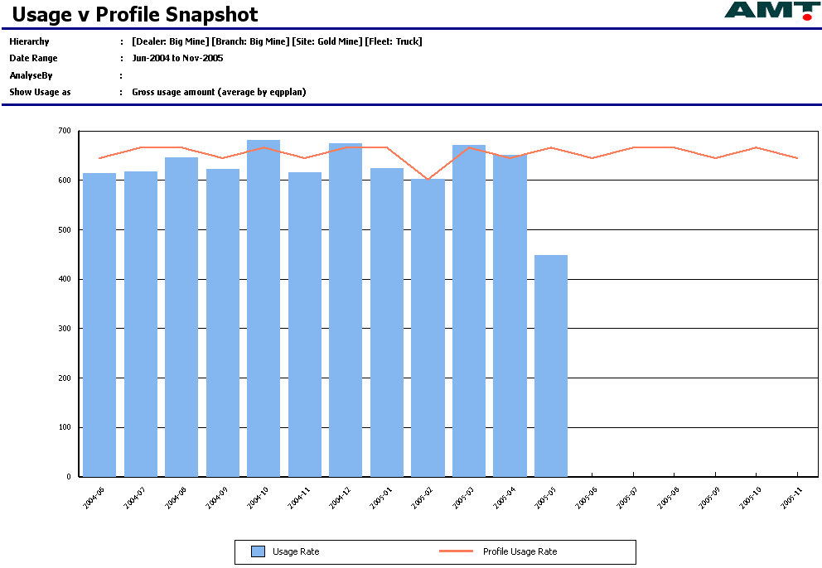
- By responsibility and Downtime classification
Usages
- Trend usage measures
- Compare against equipment profile
Utilisation
- Analyse and trend utilisation
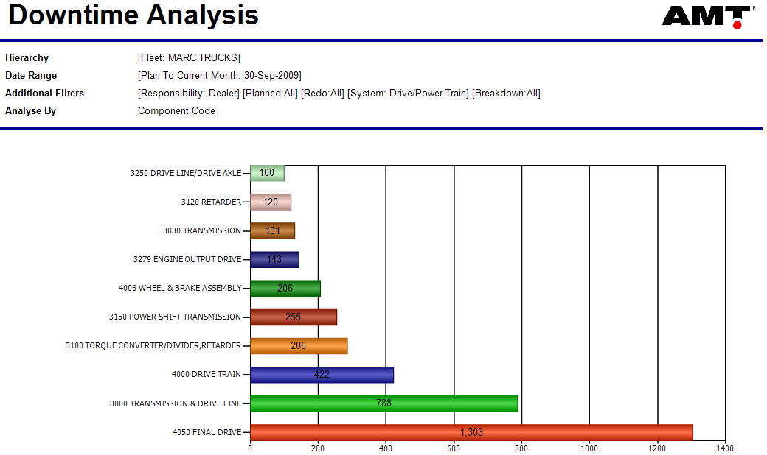
- Ie; Fuel burn rates, excavator walking time %
- Can also trend tones per engine hour
Downtime/stoppages
- Trend and analyse downtime and stoppages by cause, activity etc
Costs
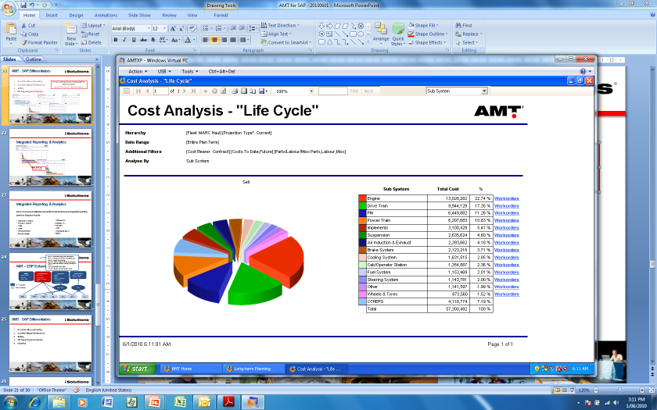
- Trend and analyse costs
- Measure cost vs budget
- Plot cost per hour
- Benchmark equipment/models

Management Monthly Reporting Maintenance Efficiency Reporting
Measures the efficiency of the equipment management organisation
One consolidated database for reporting & analytics

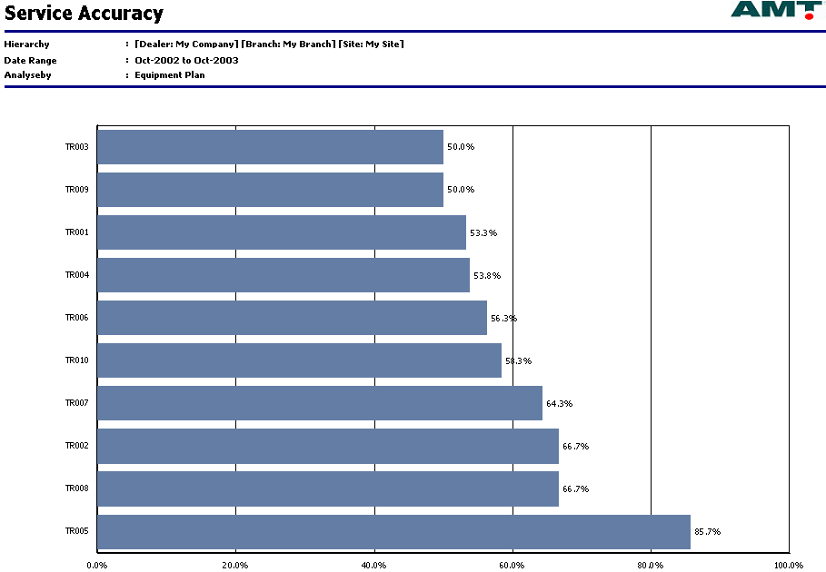
Backlog ageing
Planned downtime %
Service accuracy
Service accuracy variance
MTFS after PM
- Measures the quality of PM services
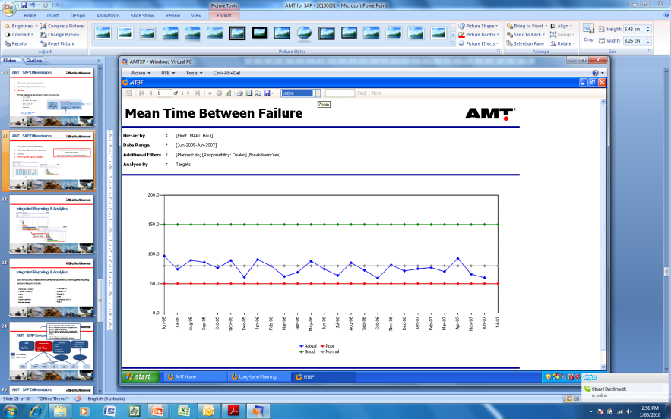
Breakdown %
Maintenance Ratio
MTTR
Unassigned cost %
Labour hours vs budget
General Analytics
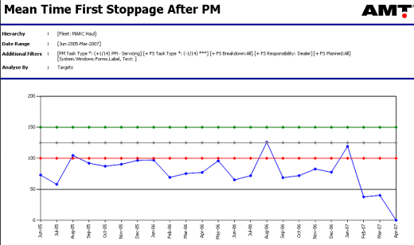
- Downtime Events
- Downtime Hours
- Tasks performed
- Labour Hours

Management Monthly Reporting Financial Reporting
- Understand Risks  - Streamlined Budgeting |  | - Lower Risk  - Improved Profitability  - Smarter Asset Replacement

Aimed at financial and maintenance managers the Financial Reporting functionality provides comprehensive financial budgeting and forecasting.
Additional functionality covers forecasting the optimal points to replace equipment.
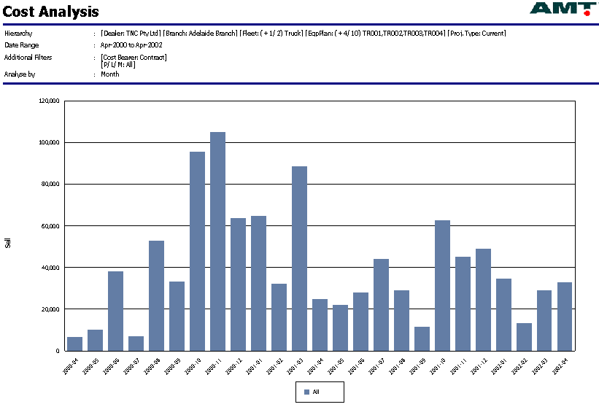
- Forecast any time period
- Includes all site costs
- Equipment specific
- Site overheads
- Also includes labour, components and productivity forecasts
- Forecast optimal points to replace equipment and produce Capex forecast
- Include Modelling equipment in budgets/forecasts

- Can prepare, save and export accounting budgets  - Can analyse budgets – down to task level by equipment  - Budgets can be linked to and driven by maintenance plans in ERP systems (ie SAP, Ellipse)  - Can maintain multiple budget scenarios | - Can evaluate actual performance v budget at any point and drill down on variances  - Can project your expected performance against budget to the end of the year (ie how you are likely to end up) and drill down on expected variances

Management Monthly Reporting AMT IC (Intelligence Centre)
Consolidate Global Data
Develop Customised Reports

AMT data is populated into a reporting “Cube” database on a schedule. This reporting database then enables customised reporting. This also enables consolidation of data from many AMT implementations for centralised reporting.

- AMT IC is a consolidated data warehouse that allows users to write their own reports
- AMT IC consists of a SQL Server database and Analysis Services cubes
- The AMT IC database is populated on a schedule from the AMT transactional database
- Cubes are also processed on a schedule
- Reports are saved onto the AMT application and are run like standard AMT reports

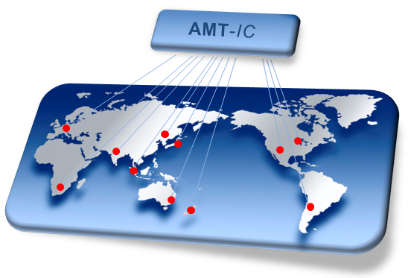

Management Daily Control Dashboard
- ‘Real Time’ KPI Reporting  - Improved Visibility  - Focus on Critical Areas |  | - Lower Risk  - Improved Profitability

Aimed at senior/middle managers the Dashboard provides a quick and easy way to review current performance levels and identify the risk areas.
Rather than having to run multiple individual reports the Dashboard allows users to open a single web-based form that summarises the KPIs. It also reduces the need for hard copy monthly reports comprised of many individual reports. Users can now focus on the relevant risk areas.

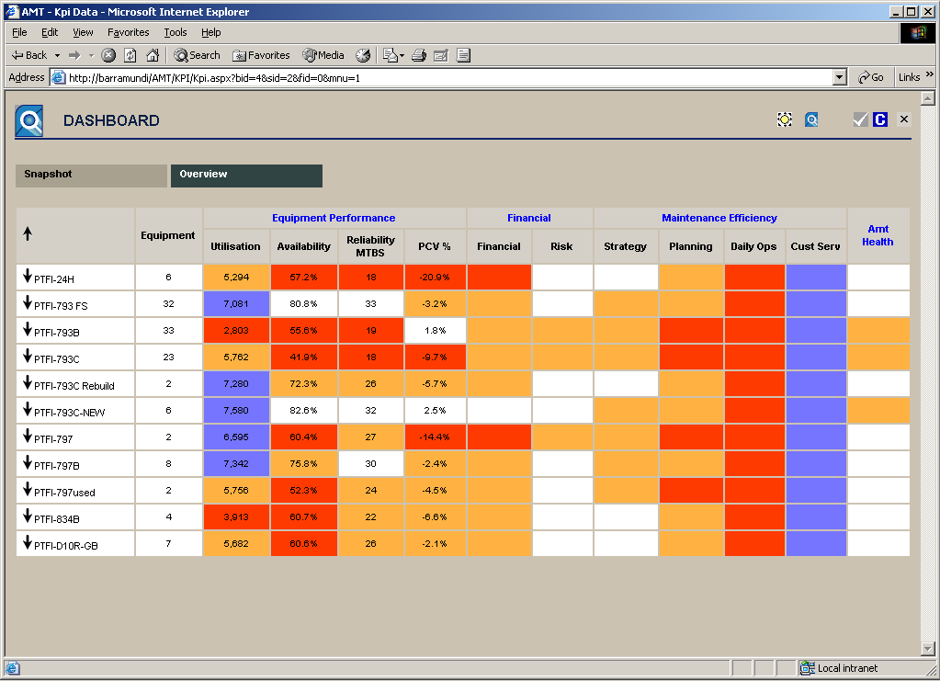
Real time
Graphical display
Snapshot shows current status and last 48 hrs
Overview shows monthly KPIs’
- Equipment performance
- Maintenance efficiency
- Financial performance
- AMT health
Drill down to equipment level
User defined targets (by fleet/model)

Management Daily Control Quick Watch
Easy identification of Potential Problems

Quick Watch provides a real-time view of performance indicators for easy identification of areas needing attention. One click and issues are identified, rather than having to interrogate AMT reports.
This provides management a powerful way to monitor key issues at a transaction level. Quick links enable easy navigation from a transaction identified by Quick Watch to the underlying records or additional information.
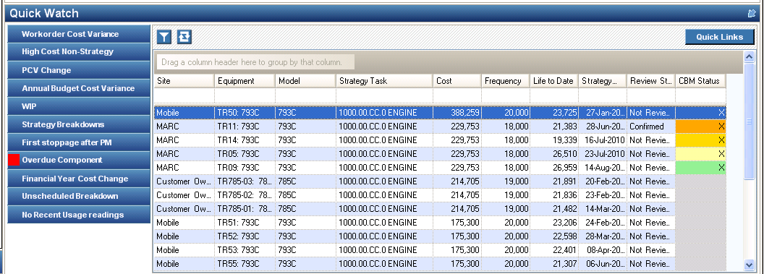

Specialised Maintenance Contracts (OEM)
One Solution for Dealers
The Benchmark in Contract Management
AMT covers all dealer requirements for Contract and equipment management.
General Line CSA/PM/TM&R | 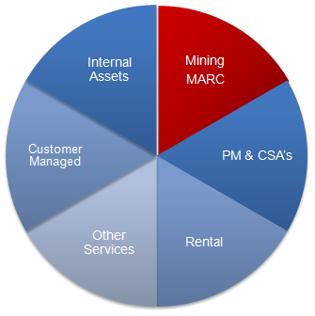  Centrally managed, high volume contracts
Mining MARC | High value, complex agreements,
Power Generation | Similar to CSAs’, focus on linkage to condition monitoring
Rental | Dealer owned assets, incorporate “absolute CPH methodology”, asset valuation
Management Services | Hosted services for customers such as component management, scheduling and planning tools
Customer managed | Track the condition of customer managed equipment to drive component forecasting and product support sales opportunities
Dealer owned assets | Management of facilities, vehicles, cranes etc
General Workshop planning | One planning system for all work requirements
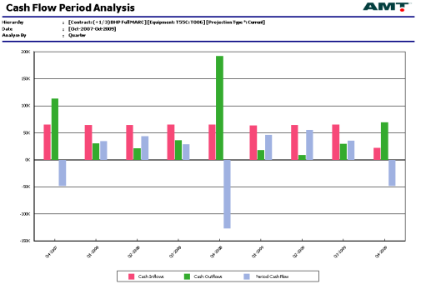
- Billing Schedules set up based on usage or period
- Handles multiple billing currencies and multiple billing steps
- Management Fee Billings and Overhead Costs.
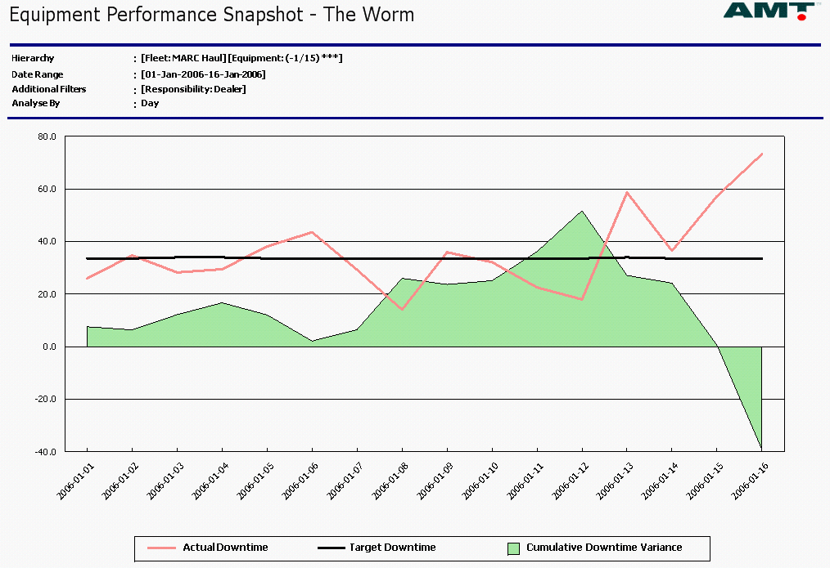
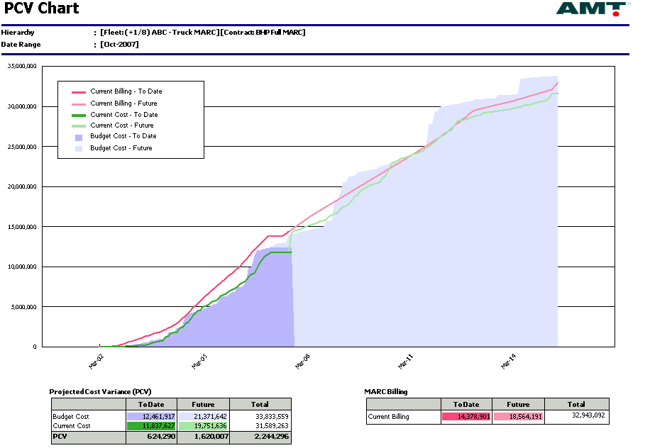
- Monthly Contract Pro Forma Invoice
- Maintenance costs expressed as both cost @ cost and cost @ sell
- Compare actual to the budgeted margins.
- Maintenance Contract P&L reports.
- Calculation of Maintenance Accrual.
- Calculation of Contract Risk.
- Cash Flow Forecast.
- Projected Cost Variance (PCV) report to show performance against original budget
- Handles Cost and Billings escalations.
- Contract Termination Analysis and reconciliation.
- Contract Downtime reconciliation.
- Calculation of available downtime to meet contract performance targets.

Specialised Plant Hire (Contractors)
Calculate Plant Hire and Rental Rates
Manage Plant Hire and Rental Equipment
Manage a Component Based Depreciation Account

Internal Plant Hire and External Rental rates can be calculated and financial performance measured against the plant hire income. A provision account can be created where a portion of the plant hire fees go to a provision account for major component repairs (CBD account). The plant rate is different to a Maintenance fee rate as it uses an absolute Cost Per hour.
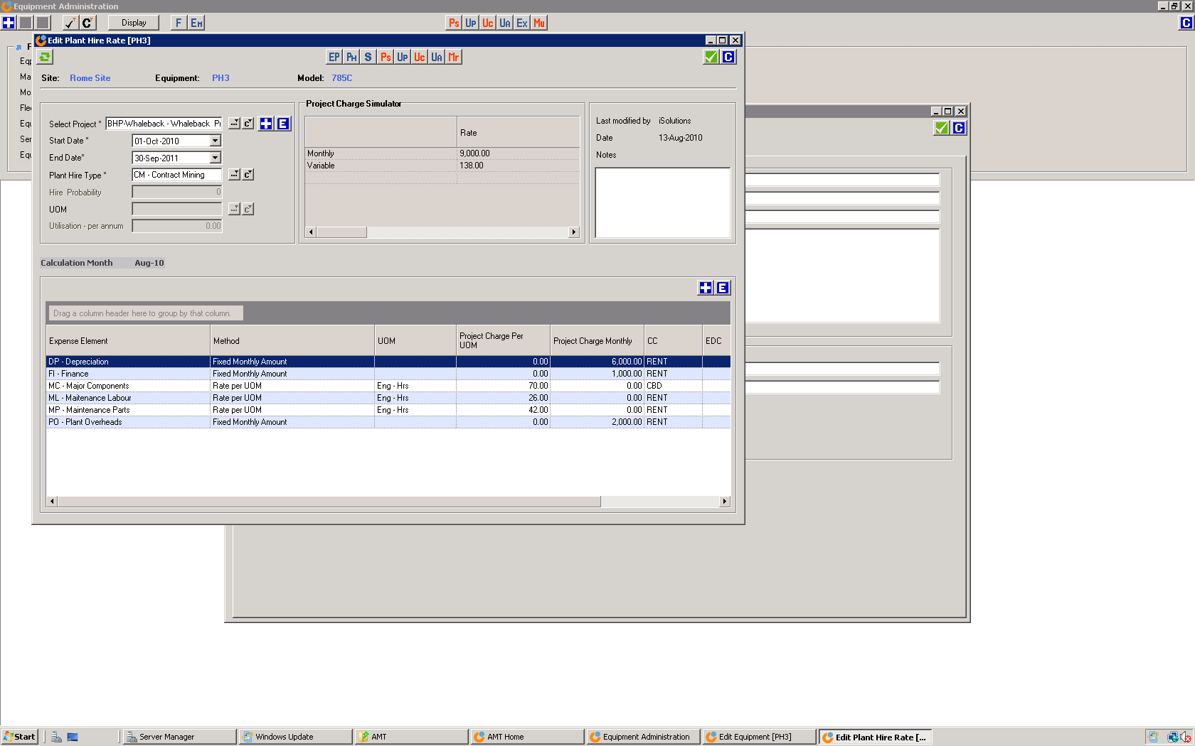
- Plant Rate Calculation  - Calculates Plant rates from life-cycle templates, can also set manually  - Applies “absolute CPH” methodology  - Asset Register  - Setup depreciation schedules  - Calculate monthly depreciation  - Equipment Assignment  - Graphical Gantt chart shows equipment project allocation  - Colours reflect “probability of assignment”  - Can update start and end dates and probability on the form  - Plant Invoicing  - Automatically calculate monthly plant invoicing  - Based on the utilisation  - User can make amendments  - Option to import monthly invoicing from external source  - Plant Recovery (Profitability)  - Detailed Plant P&L reports  - Cost v Recovery Analysis  - Component Based Depreciation (CBD)  - Depreciates components based on life utilised on that component  - Ensures monies are accrued to pay for future component change-outs  - Ie; when equipment is new a portion of the plant revenue is set aside to pay for the Engine in 3 years | 